Screenshots for all code result according to the code in same repository
Travelling Salesman Problem
This repository discuss about the Travelling Salesman Problem with the usage of 2-opt algorithm and Christofides algorithm. Exploring and comparing these algorithms, then create a merged algorithm that combine both algorithm's advantages to solve the problem in a more balanced way by balancing their runtime and stability.
2-opt algorithm with 8 points
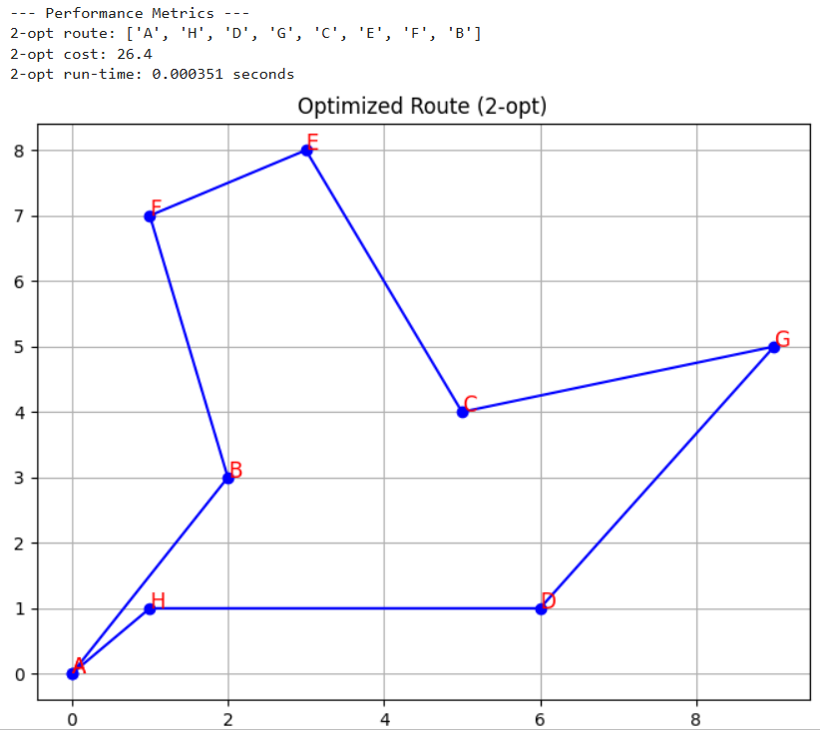
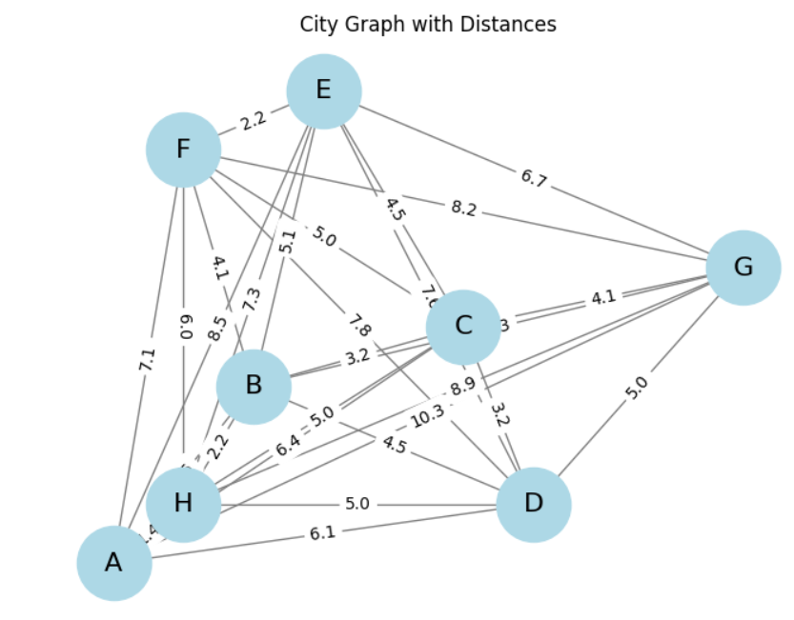

Christofides algorithm with 8 points
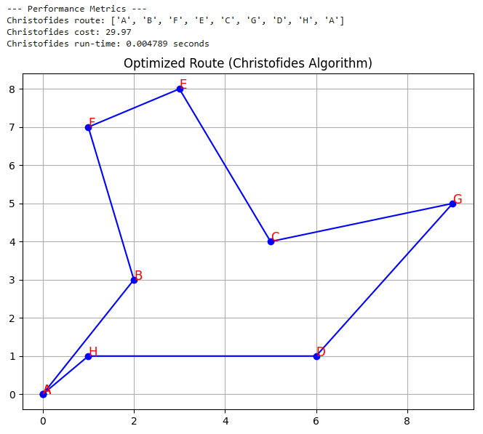
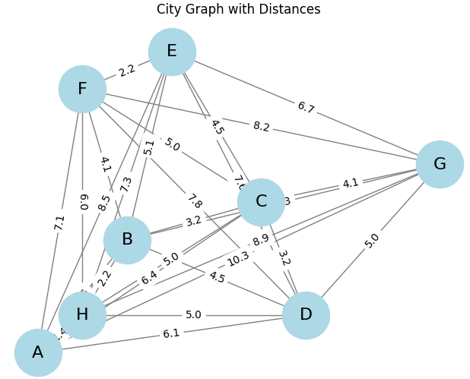

Merged Algorithm with 8 points
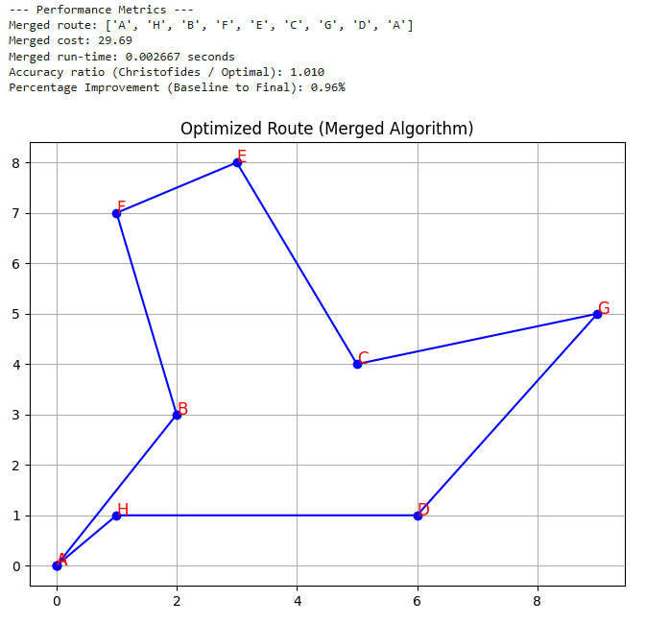
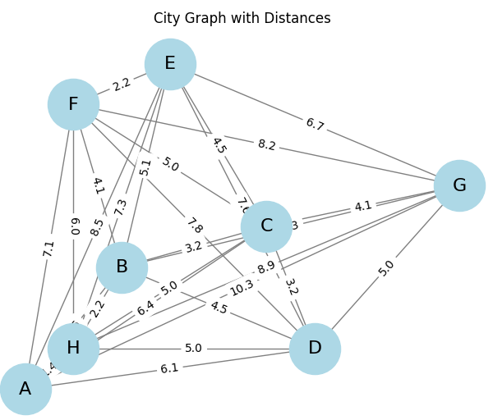
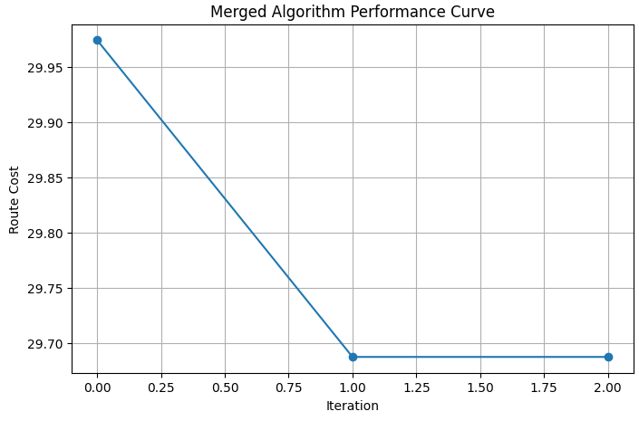
2-opt algorithm with 25 points
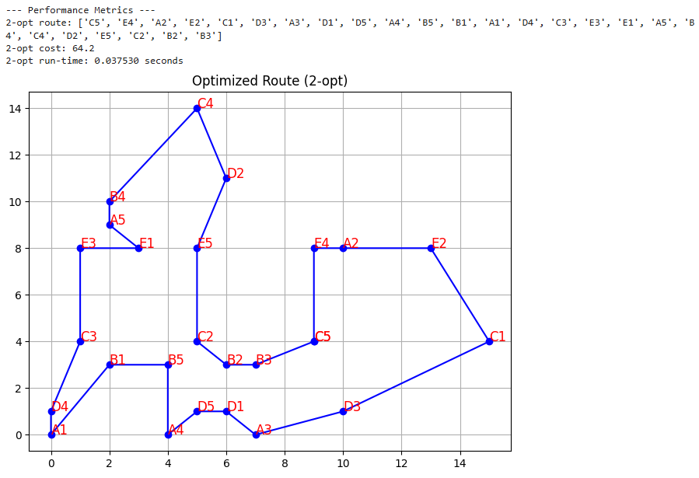
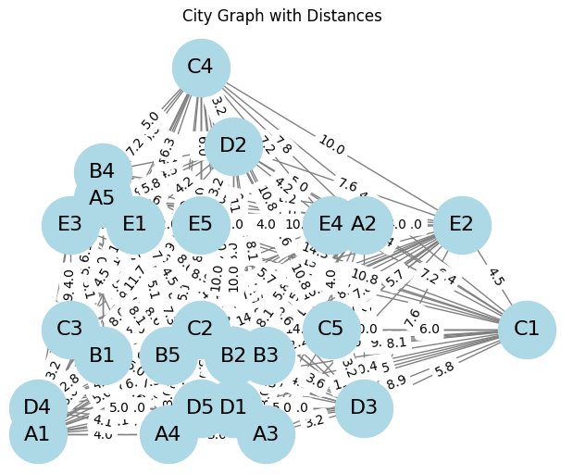

Christofides algorithm with 25 points
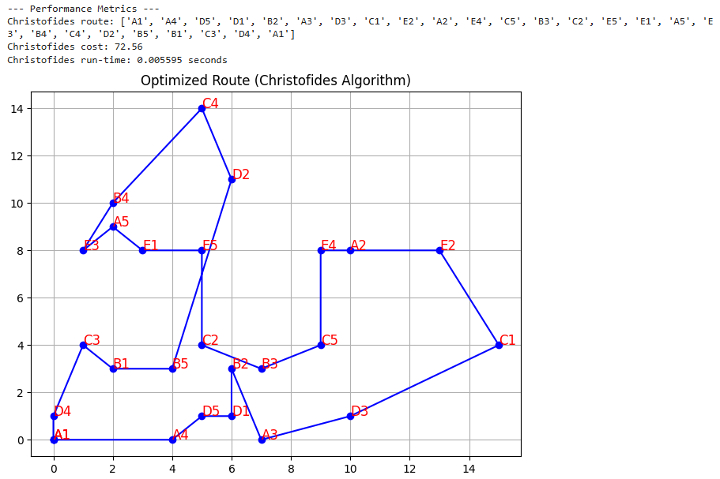
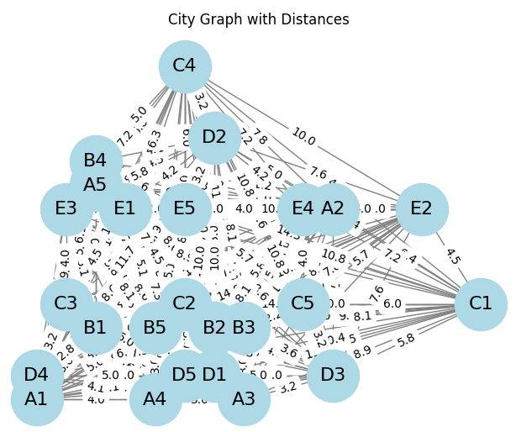

Merged algorithm with 25 points
